Hyperbolic Open Curves
# Source: AI Source: Provided by: [Data Path: Persons Table -> ID Column: 1, Name_En Column: Motasem Essam] -> From: [ChatGPT] on [7/25/2026]
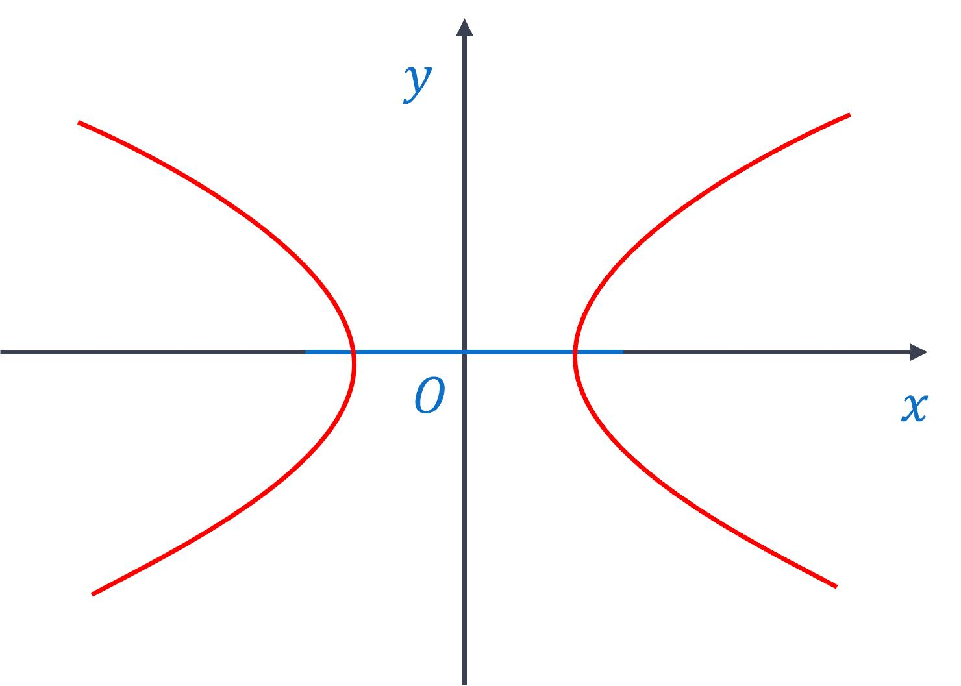
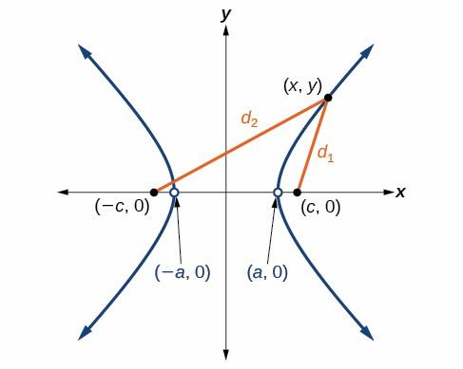
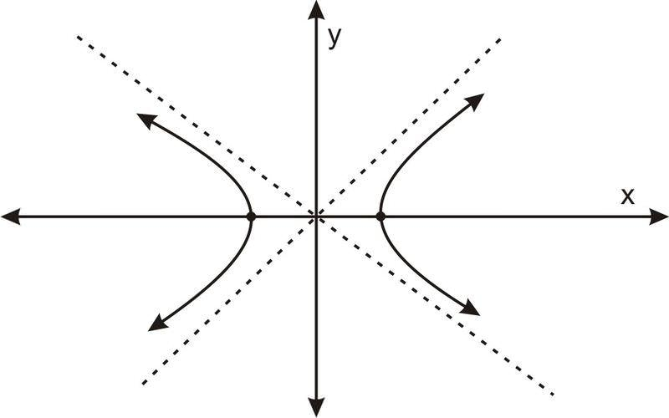
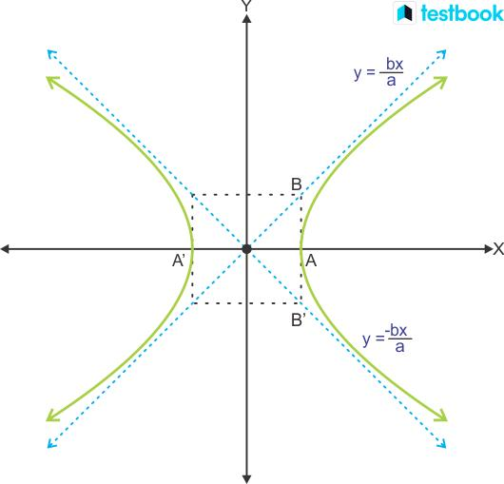
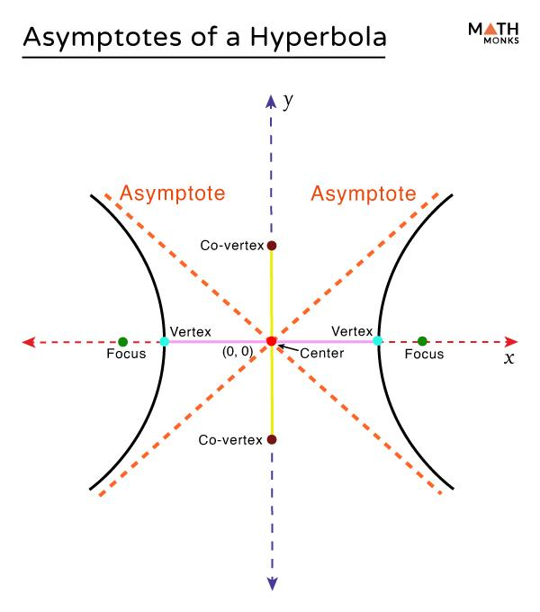

Definition
# Source: AI Source: Provided by: [Data Path: Persons Table -> ID Column: 1, Name_En Column: Motasem Essam] -> From: [ChatGPT] on [7/25/2026]
An Open Hyperbolic Curve is an open curved shape that follows one branch or part of a hyperbola. A hyperbola is a conic section consisting of two separate, open branches.
$$\boxed{\text{Hyperbolic Open Curve}=\text{Hyperbolic Form}+\text{Continuous Curvature}+\text{Open Boundary}}$$
A hyperbola is fundamentally different from a circle or ellipse because it does not form a closed boundary.

Characteristics
# Source: AI Source: Provided by: [Data Path: Persons Table -> ID Column: 1, Name_En Column: Motasem Essam] -> From: [ChatGPT] on [7/25/2026]
A Hyperbolic Open Curve:
- Is open.
- Is based on a hyperbola.
- Can consist of one branch or part of one branch.
- Has continuously changing curvature.
- Does not enclose an area by itself.
- Has a characteristic center.
- Has two asymptotes in the standard hyperbola.
- Can open horizontally or vertically.
- Can be symmetric about one or more axes.
- Can be represented by straight-line asymptotic behavior.
For a horizontal hyperbola:
$$\boxed{\frac{x^{2}}{a^{2}}-\frac{y^{2}}{b^{2}}=1}$$
For a vertical hyperbola:
$$\boxed{\frac{y^{2}}{a^{2}}-\frac{x^{2}}{b^{2}}=1}$$

Types of Hyperbolic Open Curves

1. Right-Opening Hyperbolic Curve
# Source: AI Source: Provided by: [Data Path: Persons Table -> ID Column: 1, Name_En Column: Motasem Essam] -> From: [ChatGPT] on [7/25/2026]
A branch of the hyperbola opens toward the right.
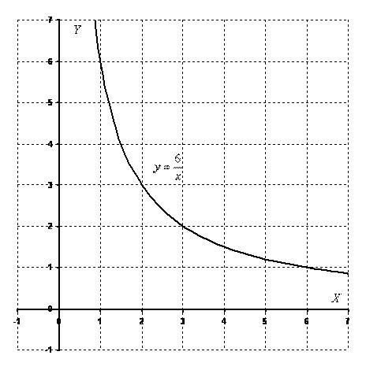
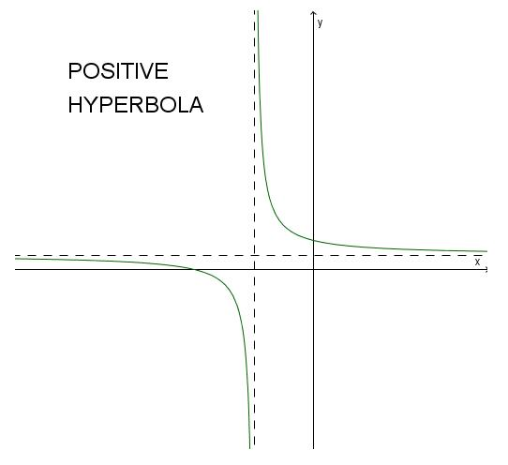
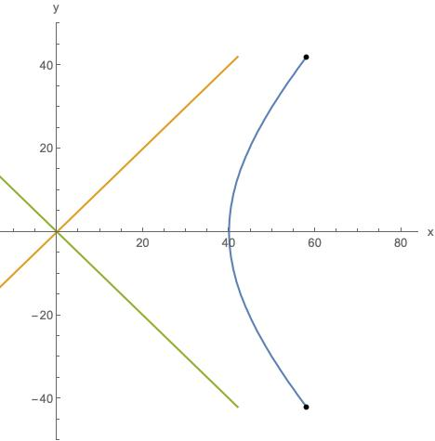
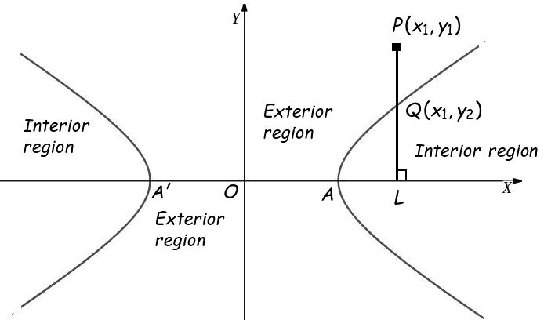
For a horizontal hyperbola, the right branch corresponds to the positive (x)-direction.

2. Left-Opening Hyperbolic Curve
# Source: AI Source: Provided by: [Data Path: Persons Table -> ID Column: 1, Name_En Column: Motasem Essam] -> From: [ChatGPT] on [7/25/2026]
A branch of the hyperbola opens toward the left.
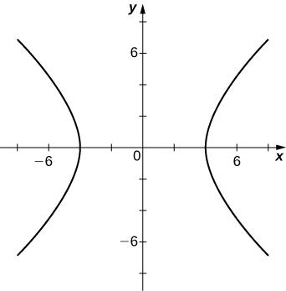
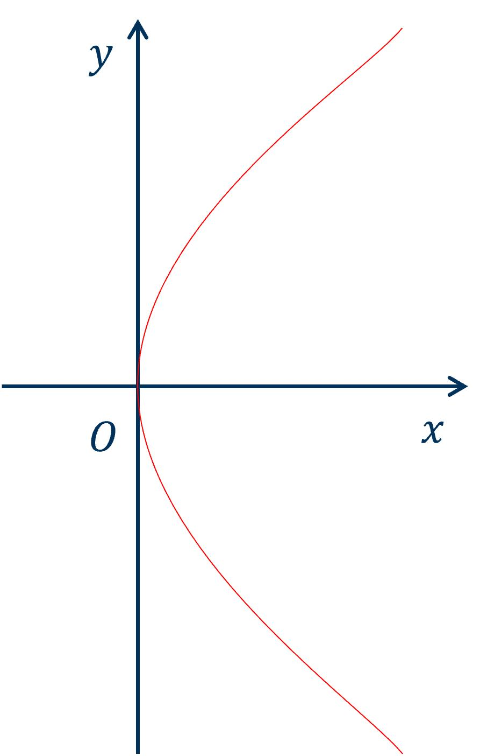
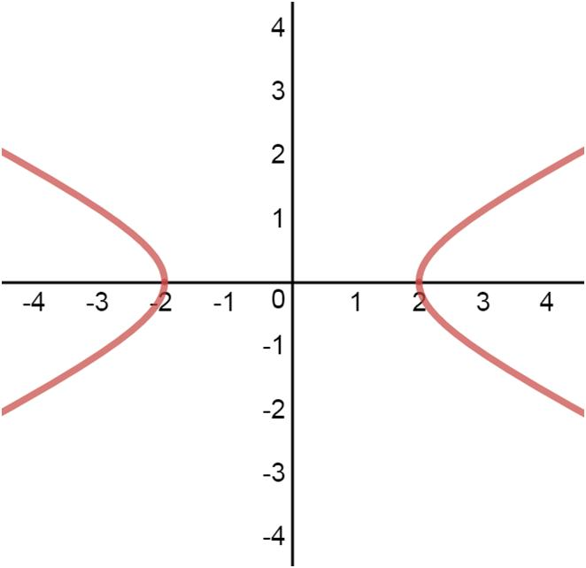
It is the opposite branch of a horizontal hyperbola.

3. Upward-Opening Hyperbolic Curve
# Source: AI Source: Provided by: [Data Path: Persons Table -> ID Column: 1, Name_En Column: Motasem Essam] -> From: [ChatGPT] on [7/25/2026]
A branch opens upward.
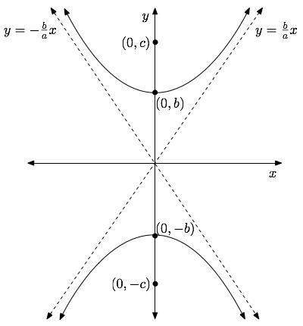
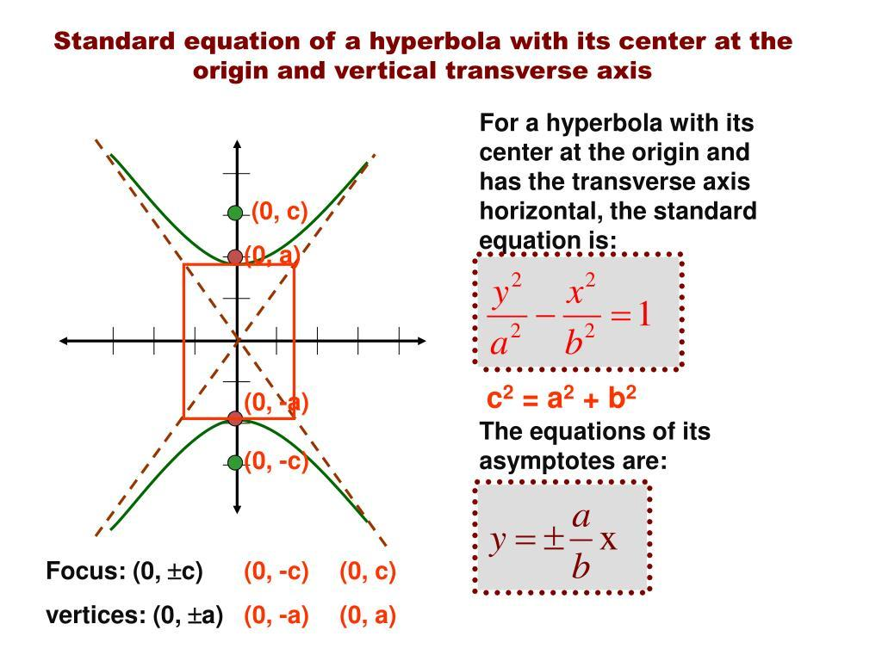
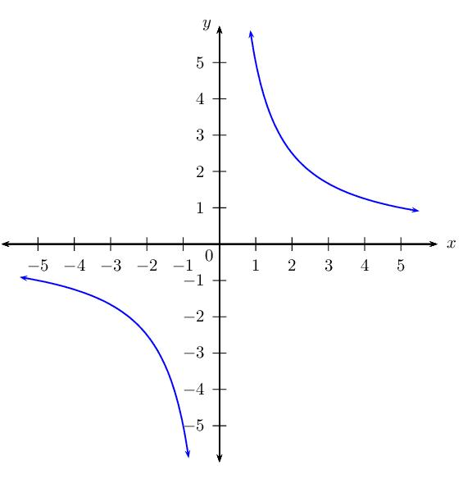
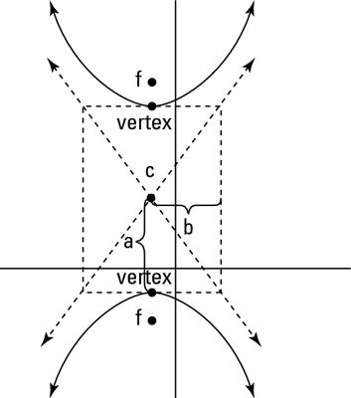
This occurs for a vertically oriented hyperbola.

4. Downward-Opening Hyperbolic Curve
# Source: AI Source: Provided by: [Data Path: Persons Table -> ID Column: 1, Name_En Column: Motasem Essam] -> From: [ChatGPT] on [7/25/2026]
A branch opens downward.
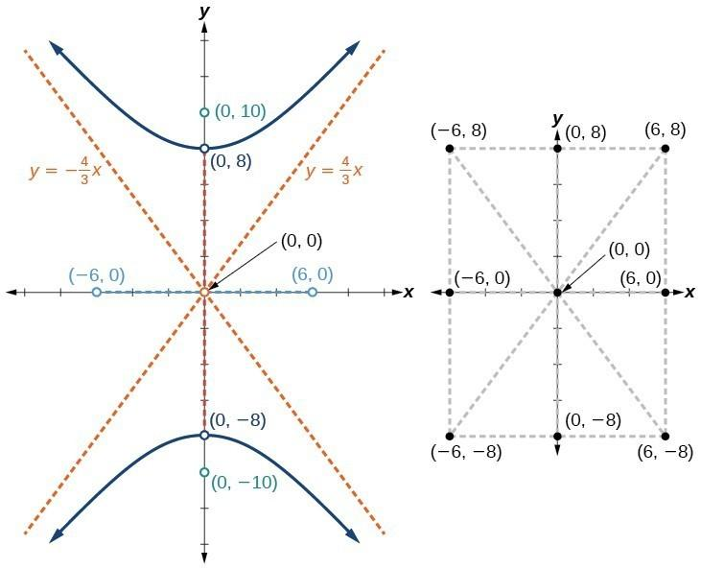
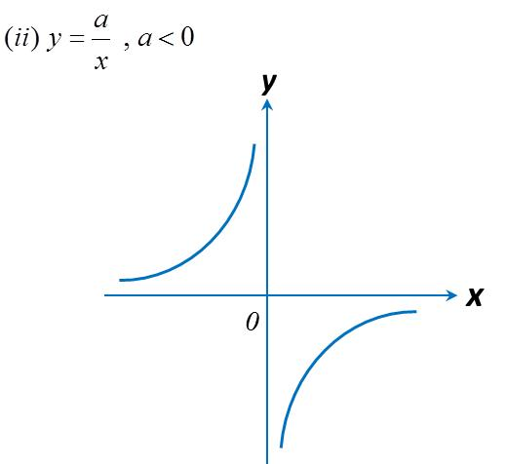
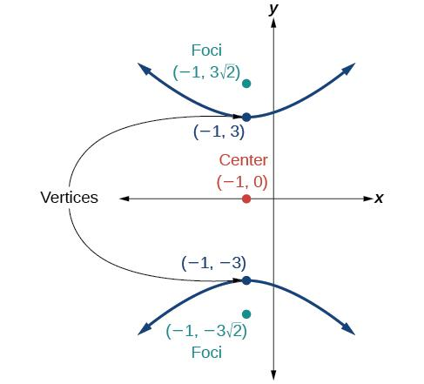
It is the opposite branch of a vertically oriented hyperbola.

5. Symmetric Hyperbolic Open Curve
# Source: AI Source: Provided by: [Data Path: Persons Table -> ID Column: 1, Name_En Column: Motasem Essam] -> From: [ChatGPT] on [7/25/2026]
A hyperbolic branch or selected portion can exhibit symmetry about the hyperbola's axes.
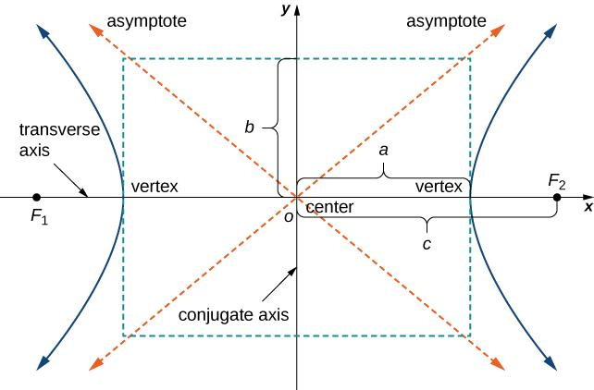
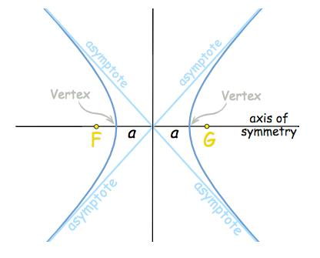
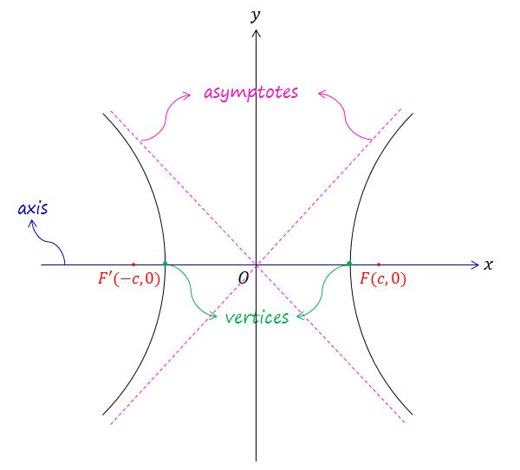
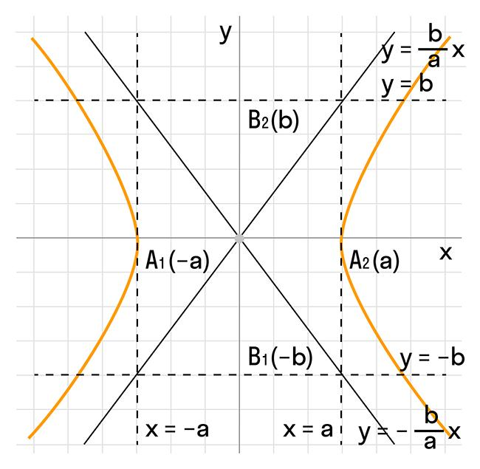
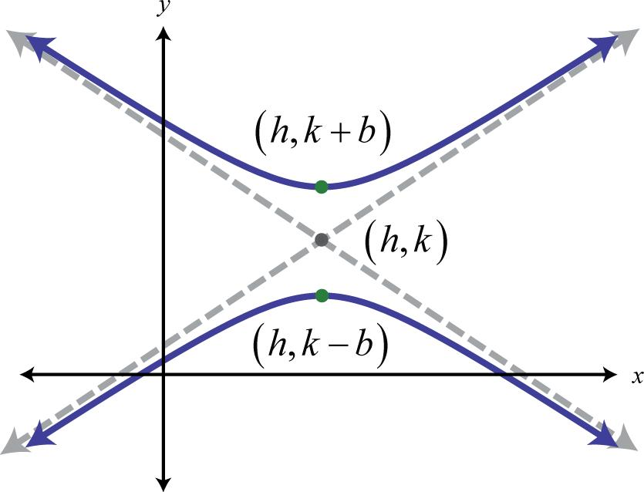
A standard hyperbola has symmetry about its transverse and conjugate axes.

6. Asymmetric Hyperbolic Open Curve
# Source: AI Source: Provided by: [Data Path: Persons Table -> ID Column: 1, Name_En Column: Motasem Essam] -> From: [ChatGPT] on [7/25/2026]
A selected finite portion of a hyperbolic branch can appear asymmetric.
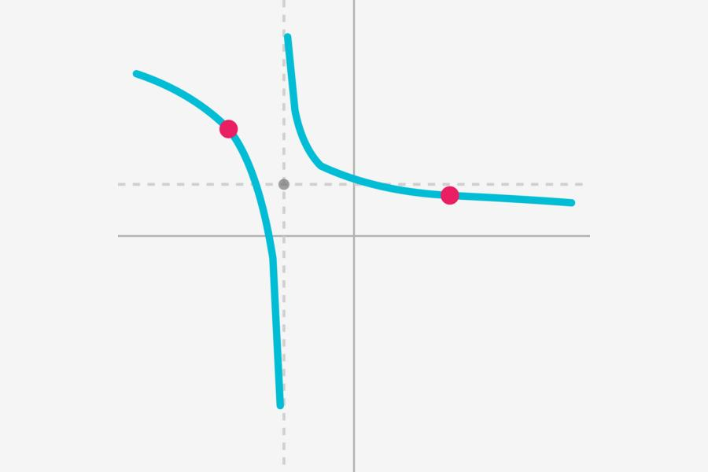
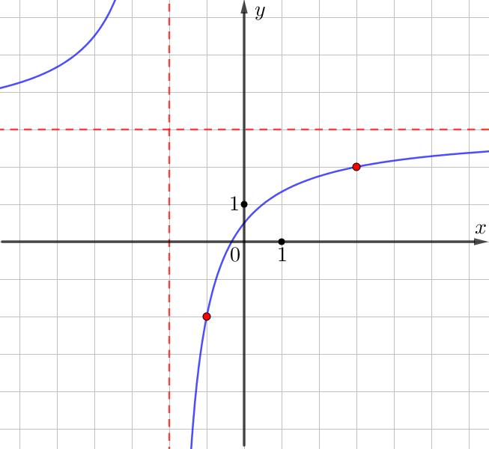
The underlying hyperbola can remain symmetric even when only an asymmetric portion is selected.

7. Short Hyperbolic Arc
# Source: AI Source: Provided by: [Data Path: Persons Table -> ID Column: 1, Name_En Column: Motasem Essam] -> From: [ChatGPT] on [7/25/2026]
A relatively small portion of one hyperbolic branch between two selected endpoints.
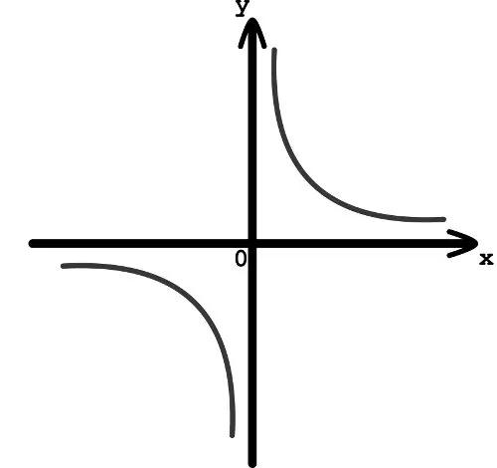
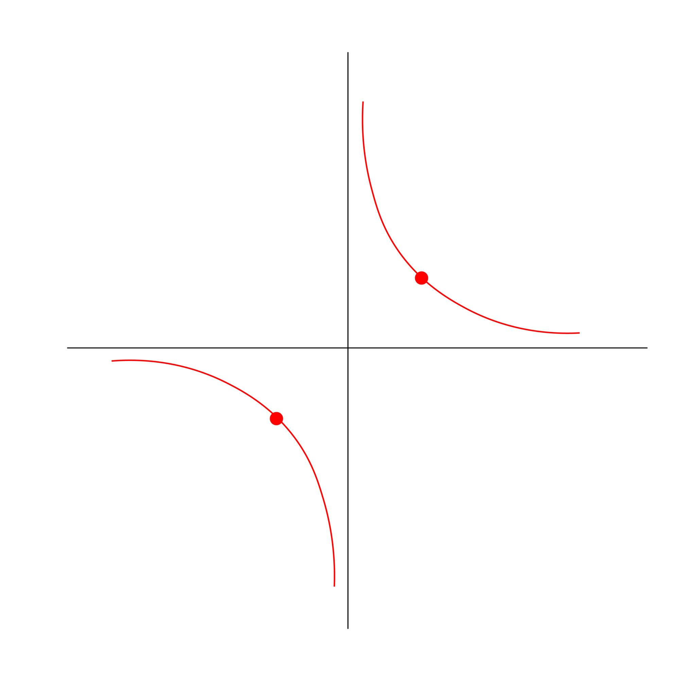
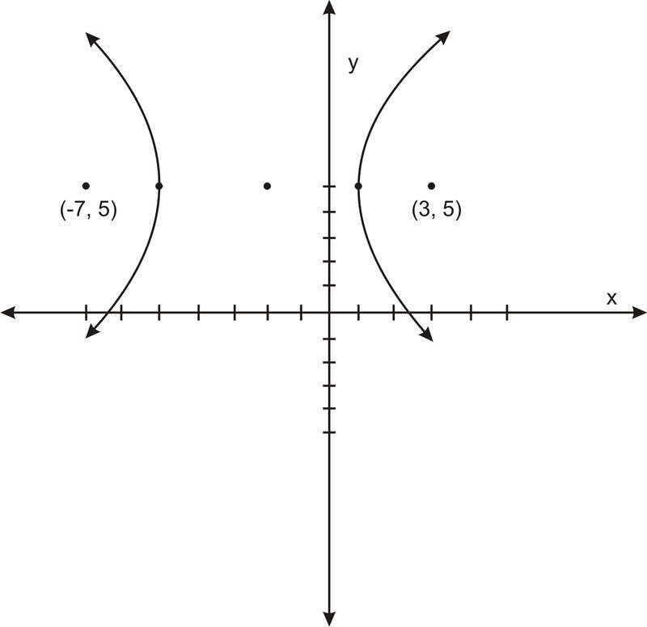
This can be used as a component of a larger geometric or freeform shape.

8. Long Hyperbolic Arc
# Source: AI Source: Provided by: [Data Path: Persons Table -> ID Column: 1, Name_En Column: Motasem Essam] -> From: [ChatGPT] on [7/25/2026]
A larger finite portion of a hyperbolic branch.
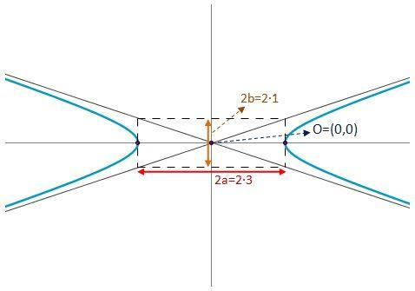
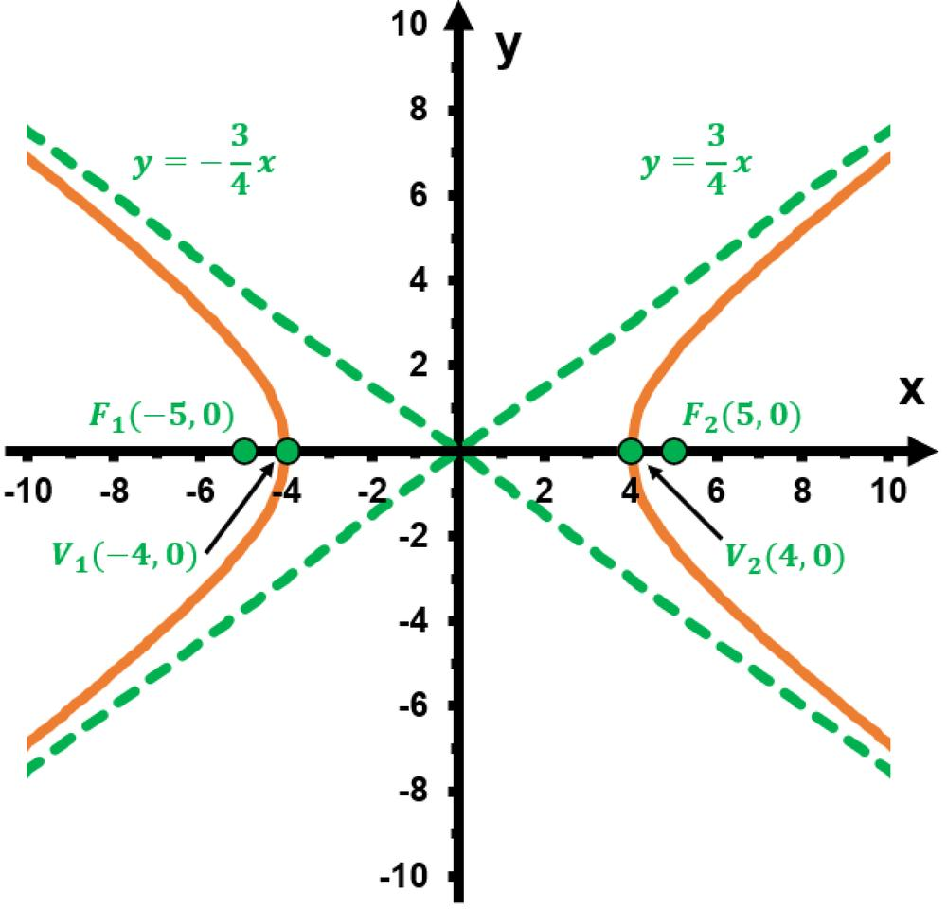
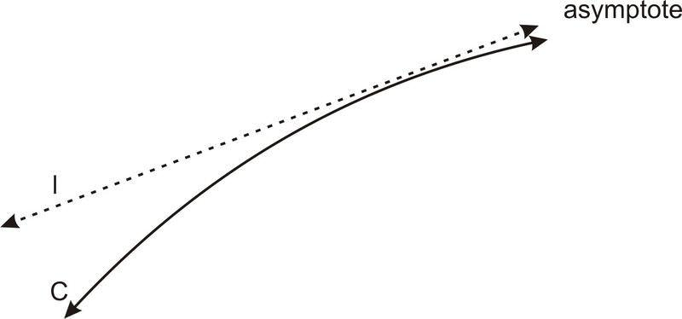
It follows the hyperbola over a greater interval while remaining open.

9. Single-Branch Hyperbolic Curve
# Source: AI Source: Provided by: [Data Path: Persons Table -> ID Column: 1, Name_En Column: Motasem Essam] -> From: [ChatGPT] on [7/25/2026]
One complete branch of a hyperbola is treated as the open curve.
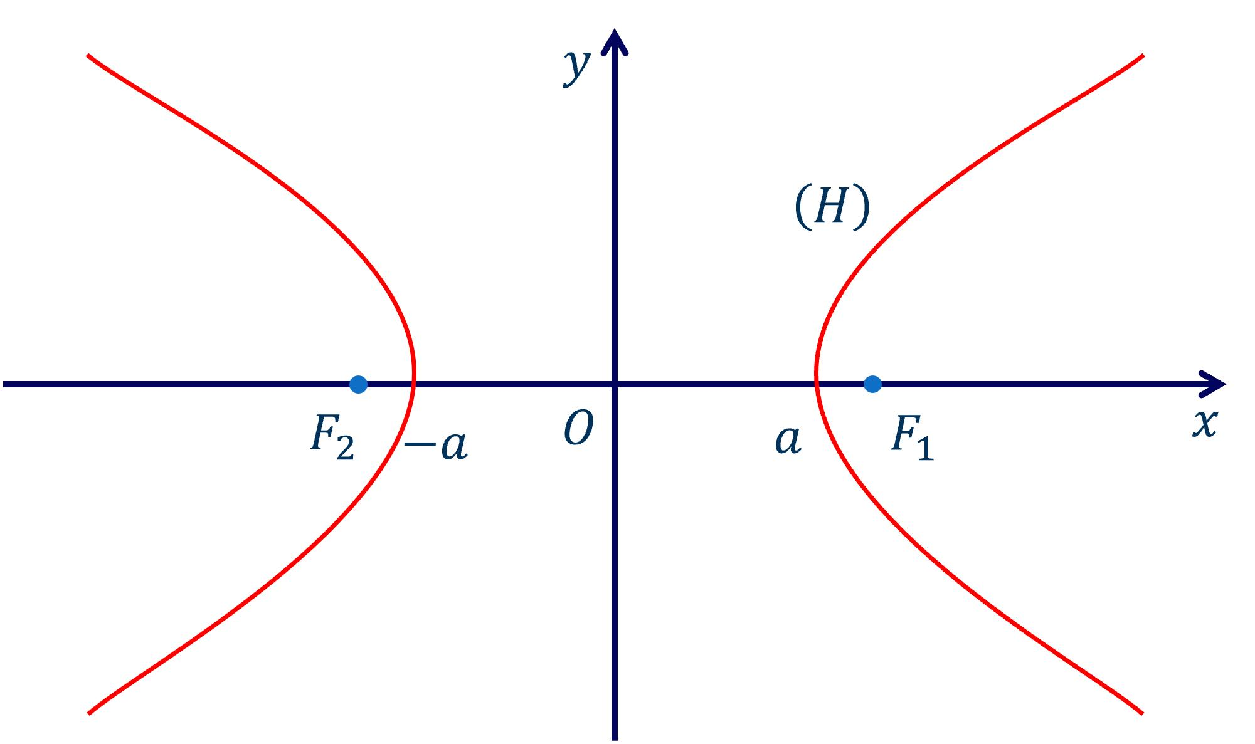
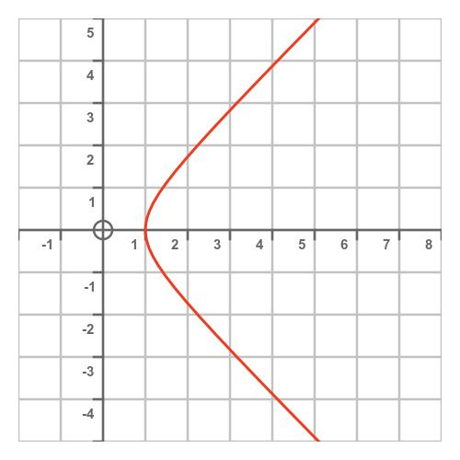
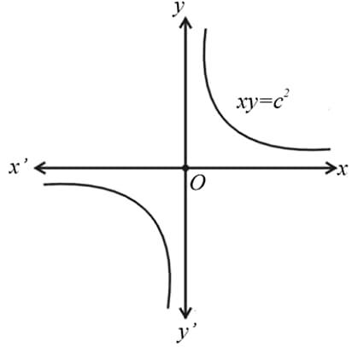
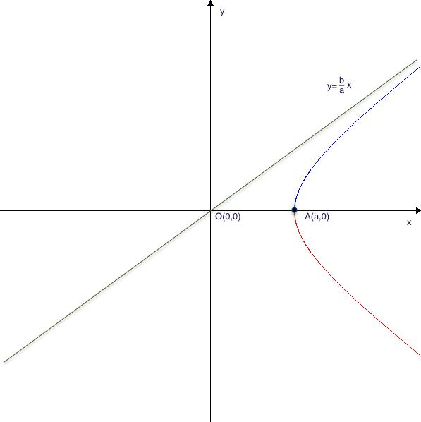
A single branch extends indefinitely and never closes.

10. Asymptotic Hyperbolic Curve
# Source: AI Source: Provided by: [Data Path: Persons Table -> ID Column: 1, Name_En Column: Motasem Essam] -> From: [ChatGPT] on [7/25/2026]
A hyperbolic curve approaches two asymptotes without touching them in the ordinary nondegenerate case.
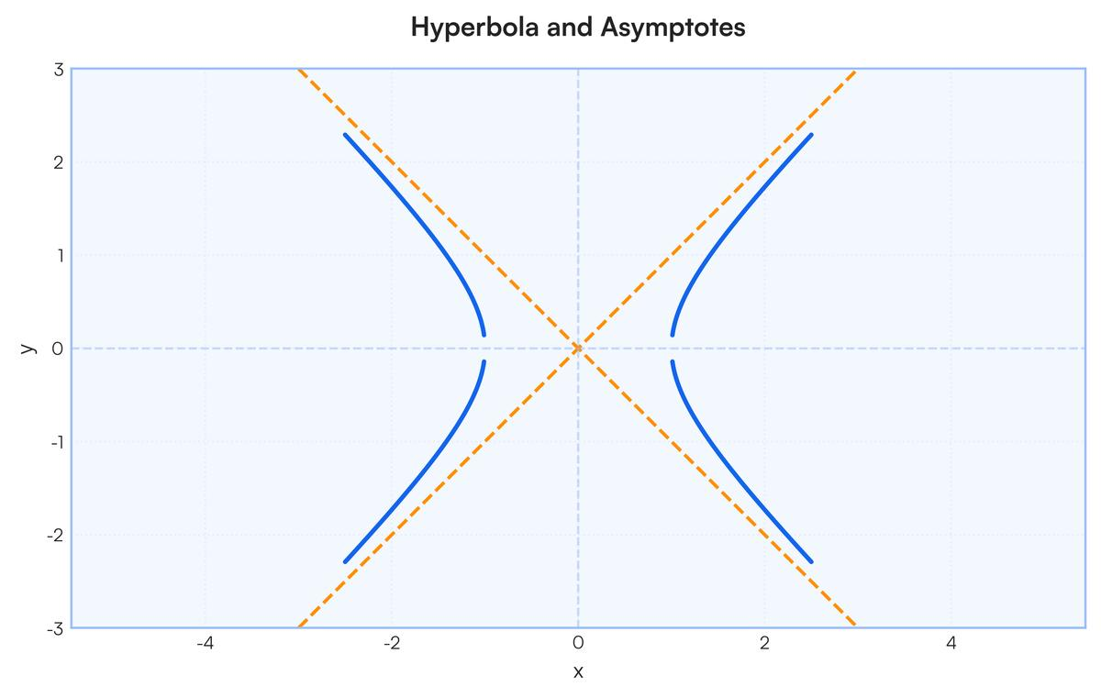
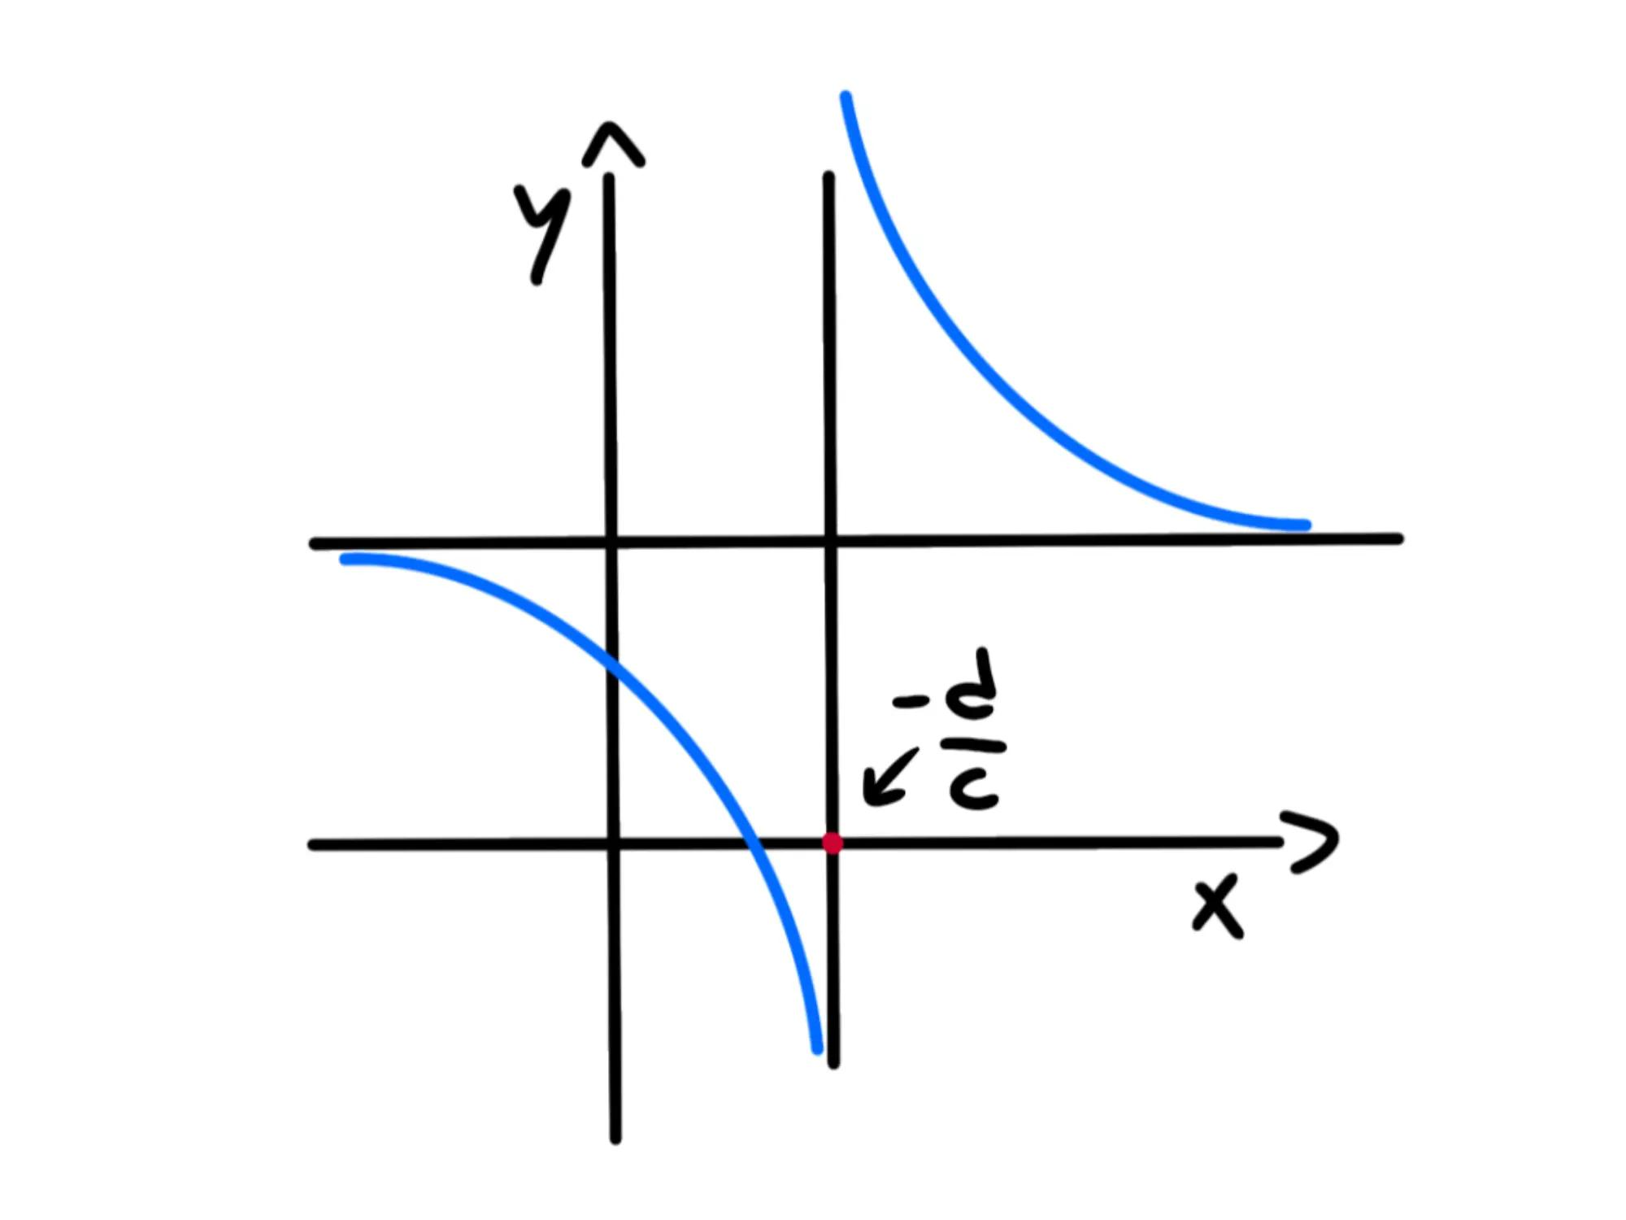
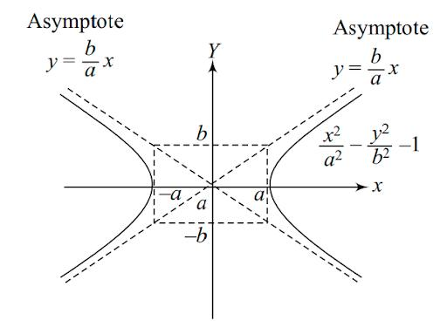
For:
[
$$\frac{x^{2}}{a^{2}}-\frac{y^{2}}{b^{2}}=1$$]
the asymptotes are:
$$\boxed{y=±\frac{b}{a}x}$$

11. Reciprocal Hyperbolic Curve
# Source: AI Source: Provided by: [Data Path: Persons Table -> ID Column: 1, Name_En Column: Motasem Essam] -> From: [ChatGPT] on [7/25/2026]
A rectangular hyperbola can be represented by:
$$\boxed{y=\frac{k}{x}}$$
where $k≠0$.
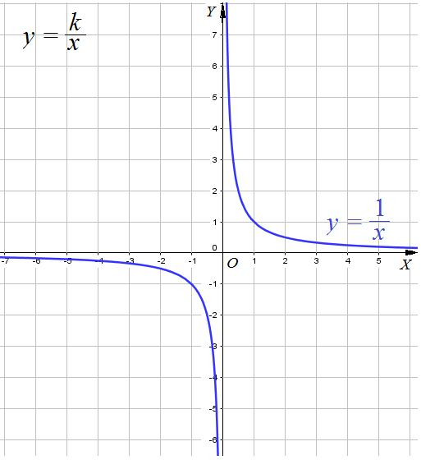
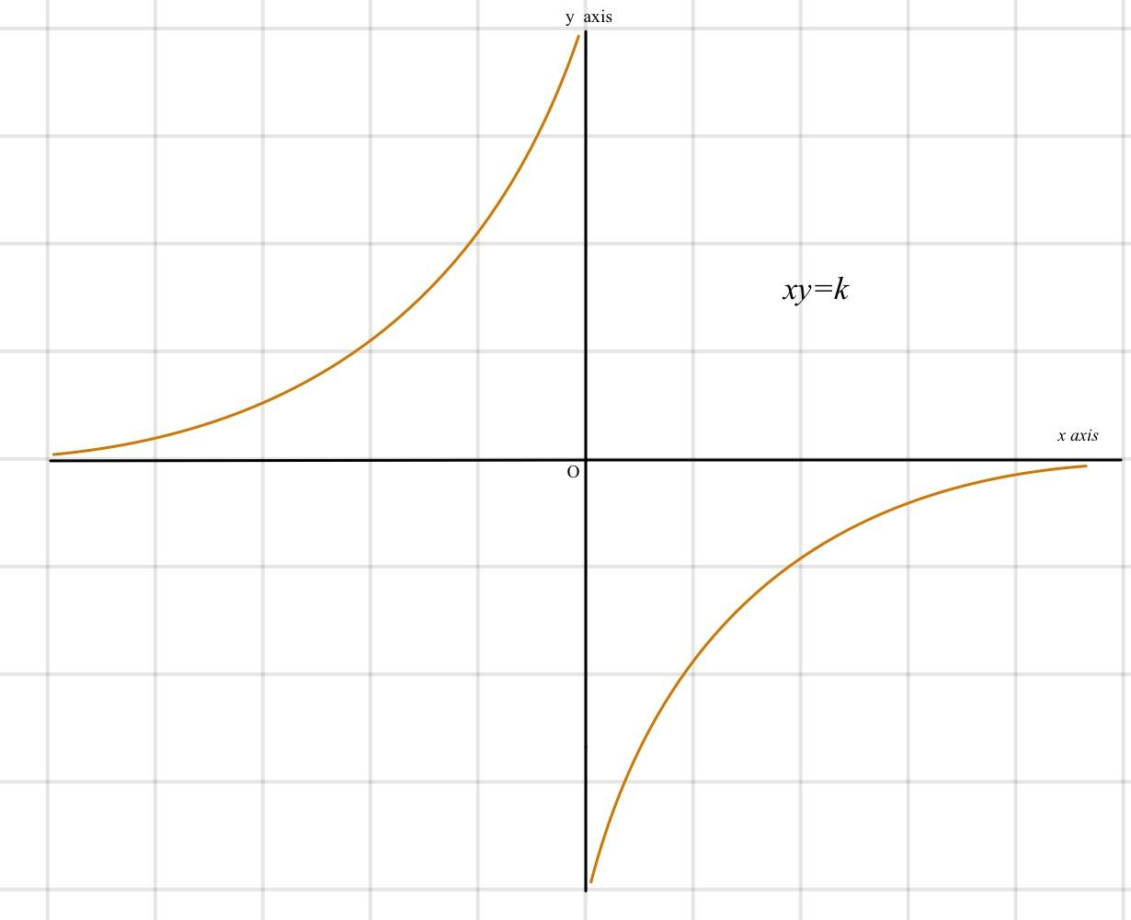
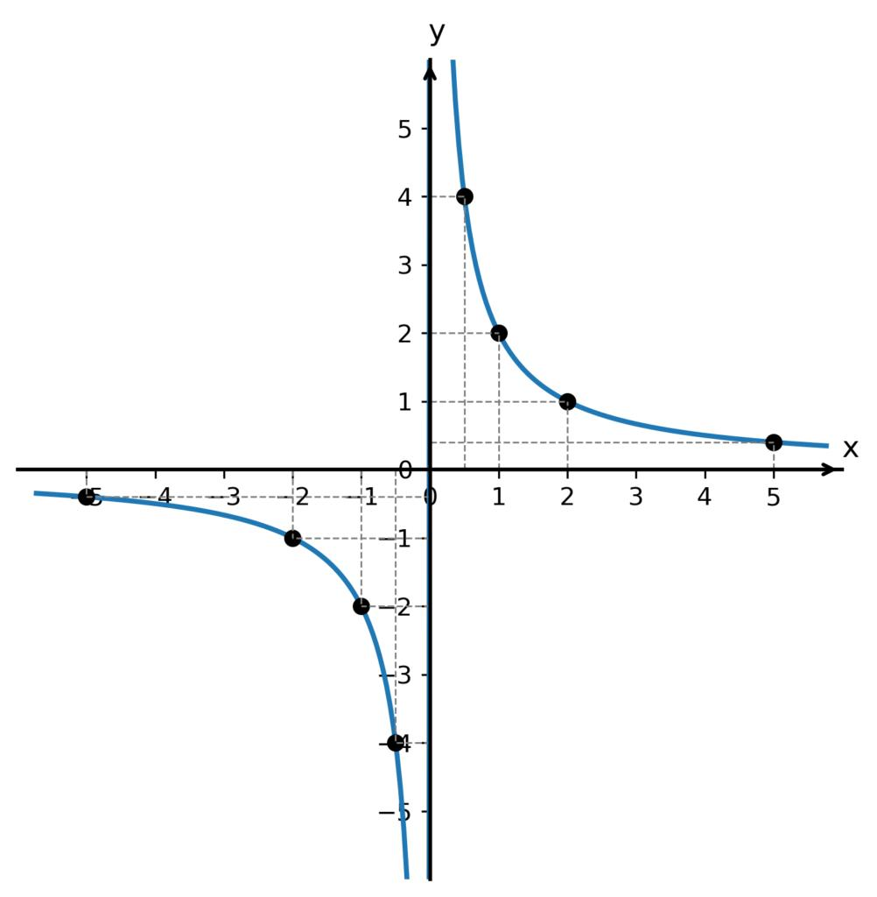
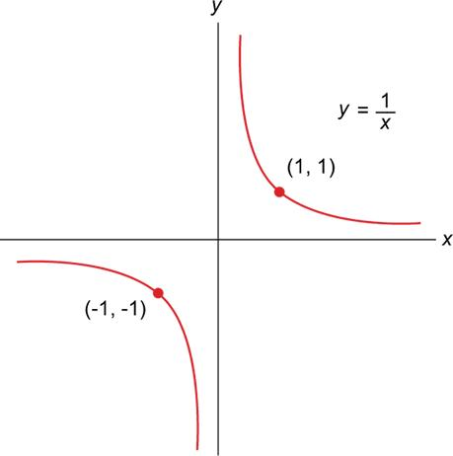
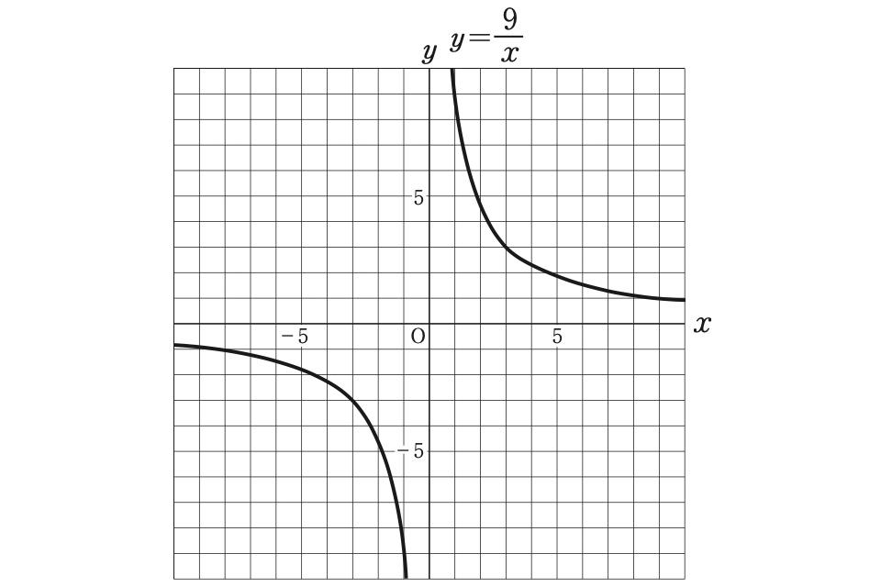
This is one of the most common hyperbolic curves encountered in mathematics.

12. Rotated Hyperbolic Open Curve
# Source: AI Source: Provided by: [Data Path: Persons Table -> ID Column: 1, Name_En Column: Motasem Essam] -> From: [ChatGPT] on [7/25/2026]
A hyperbola can be rotated so that its axes are not aligned with the horizontal and vertical coordinate axes.
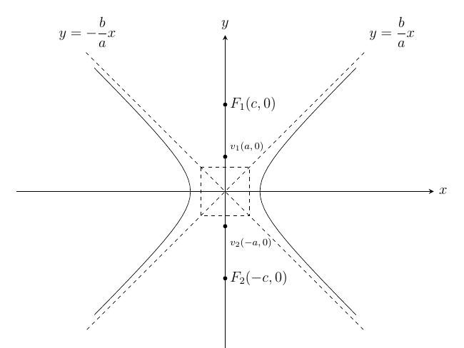
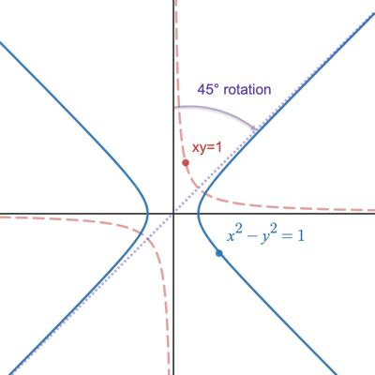
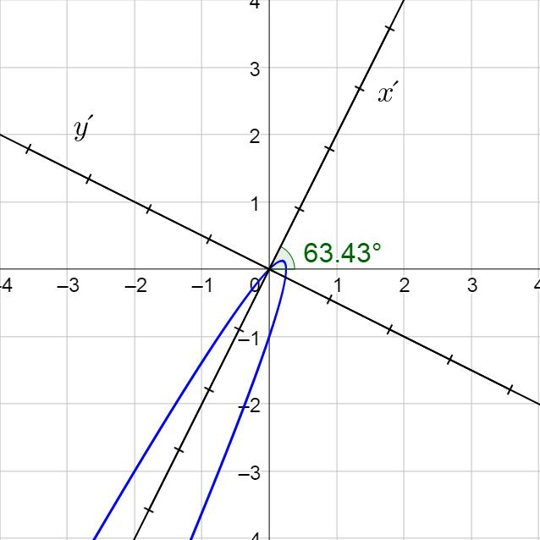
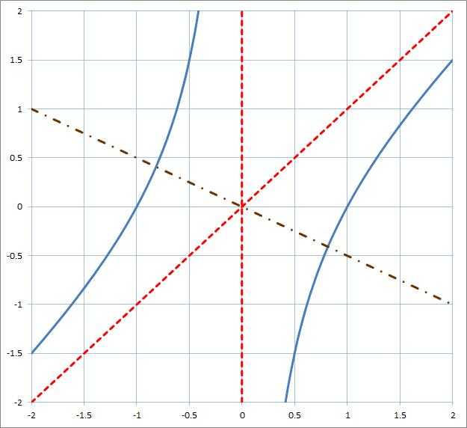
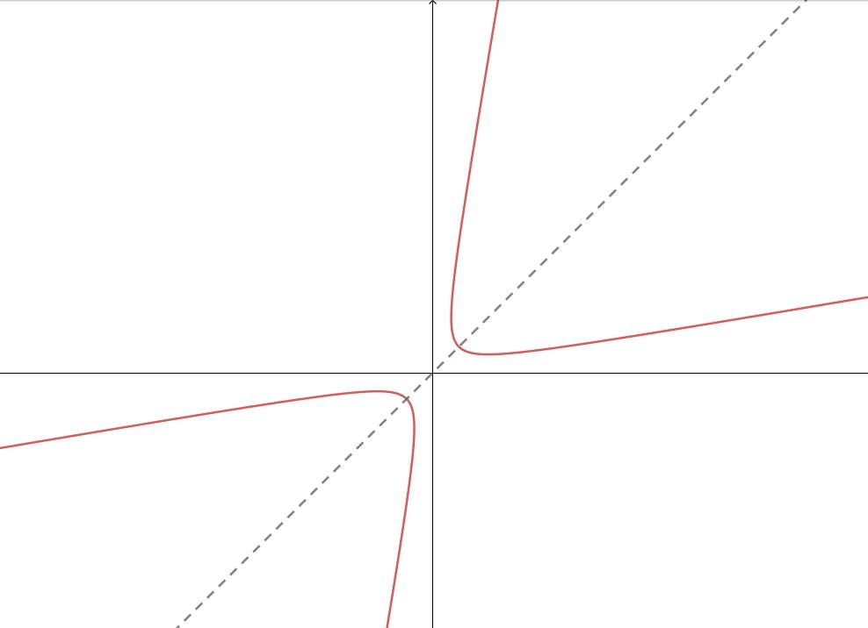
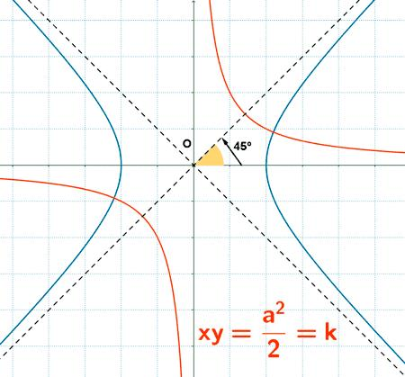
Its branches remain open, but the entire figure is oriented at an angle.

Hyperbolic Curve vs. Parabolic Curve
# Source: AI Source: Provided by: [Data Path: Persons Table -> ID Column: 1, Name_En Column: Motasem Essam] -> From: [ChatGPT] on [7/25/2026]
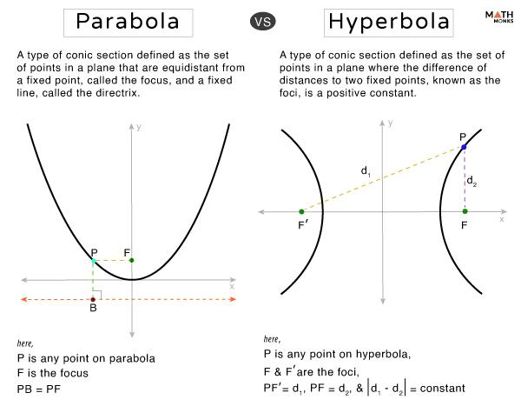
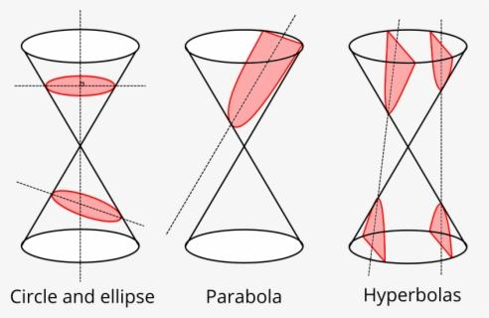
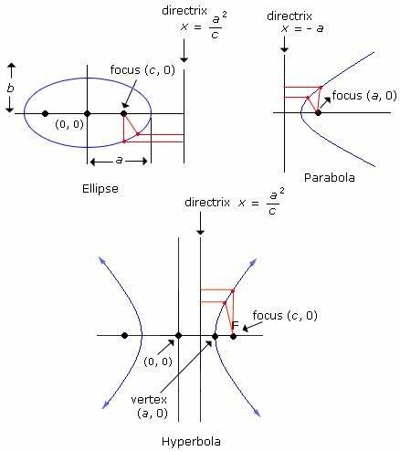
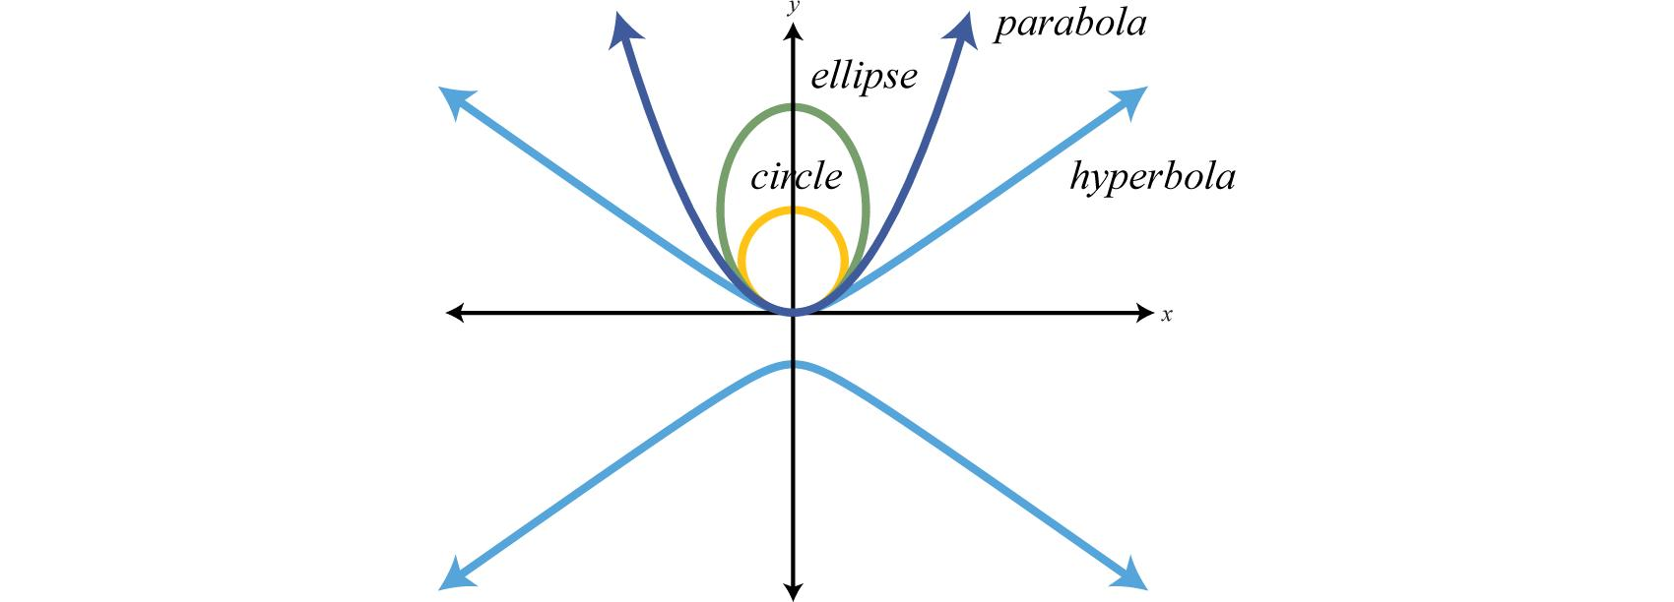
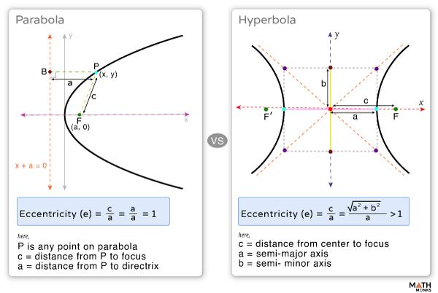
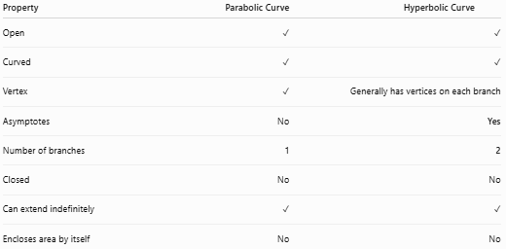
Property | Parabolic Curve | Hyperbolic Curve
Open | ✓ | ✓
Curved | ✓ | ✓
Vertex | ✓ | Generally has vertices on each branch
Asymptotes | No | Yes
Number of branches | 1 | 2
Closed | No | No
Can extend indefinitely | ✓ | ✓
Encloses area by itself | No | No

Hyperbolic Curve vs. Elliptical Curve
# Source: AI Source: Provided by: [Data Path: Persons Table -> ID Column: 1, Name_En Column: Motasem Essam] -> From: [ChatGPT] on [7/25/2026]
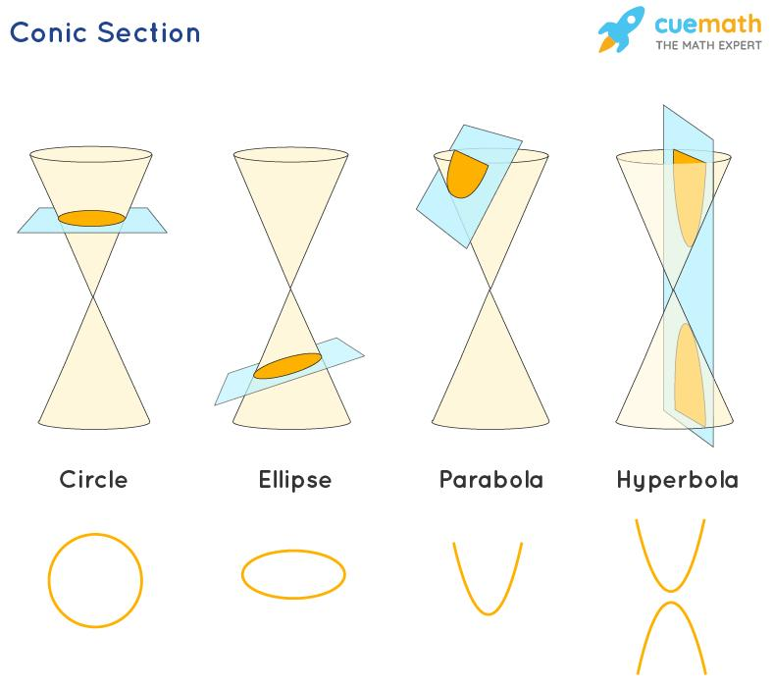
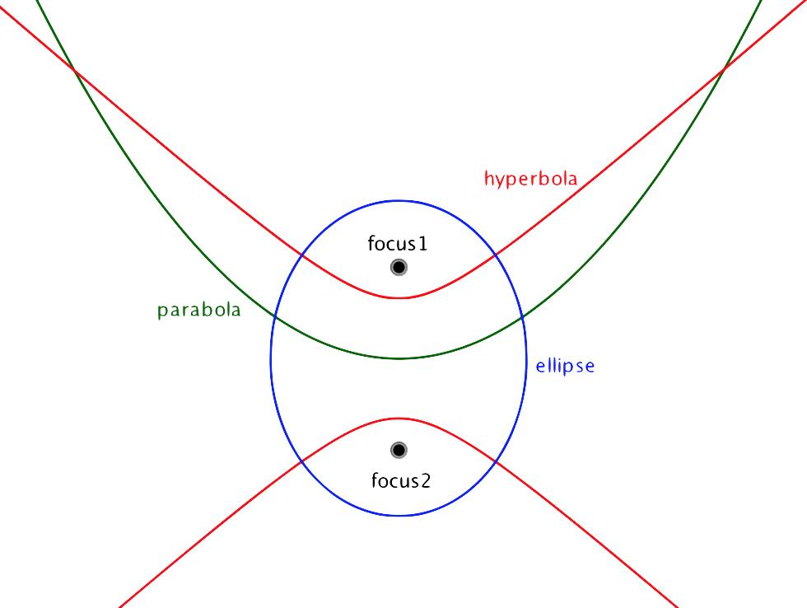
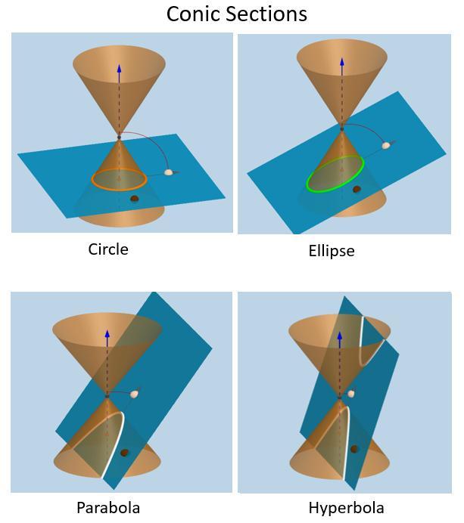
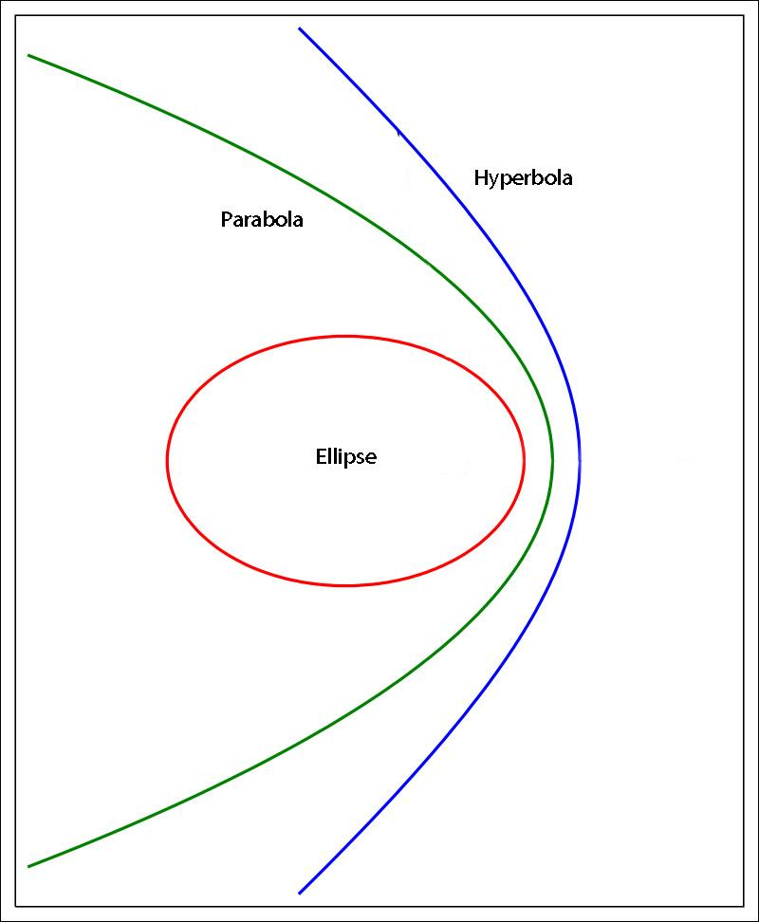
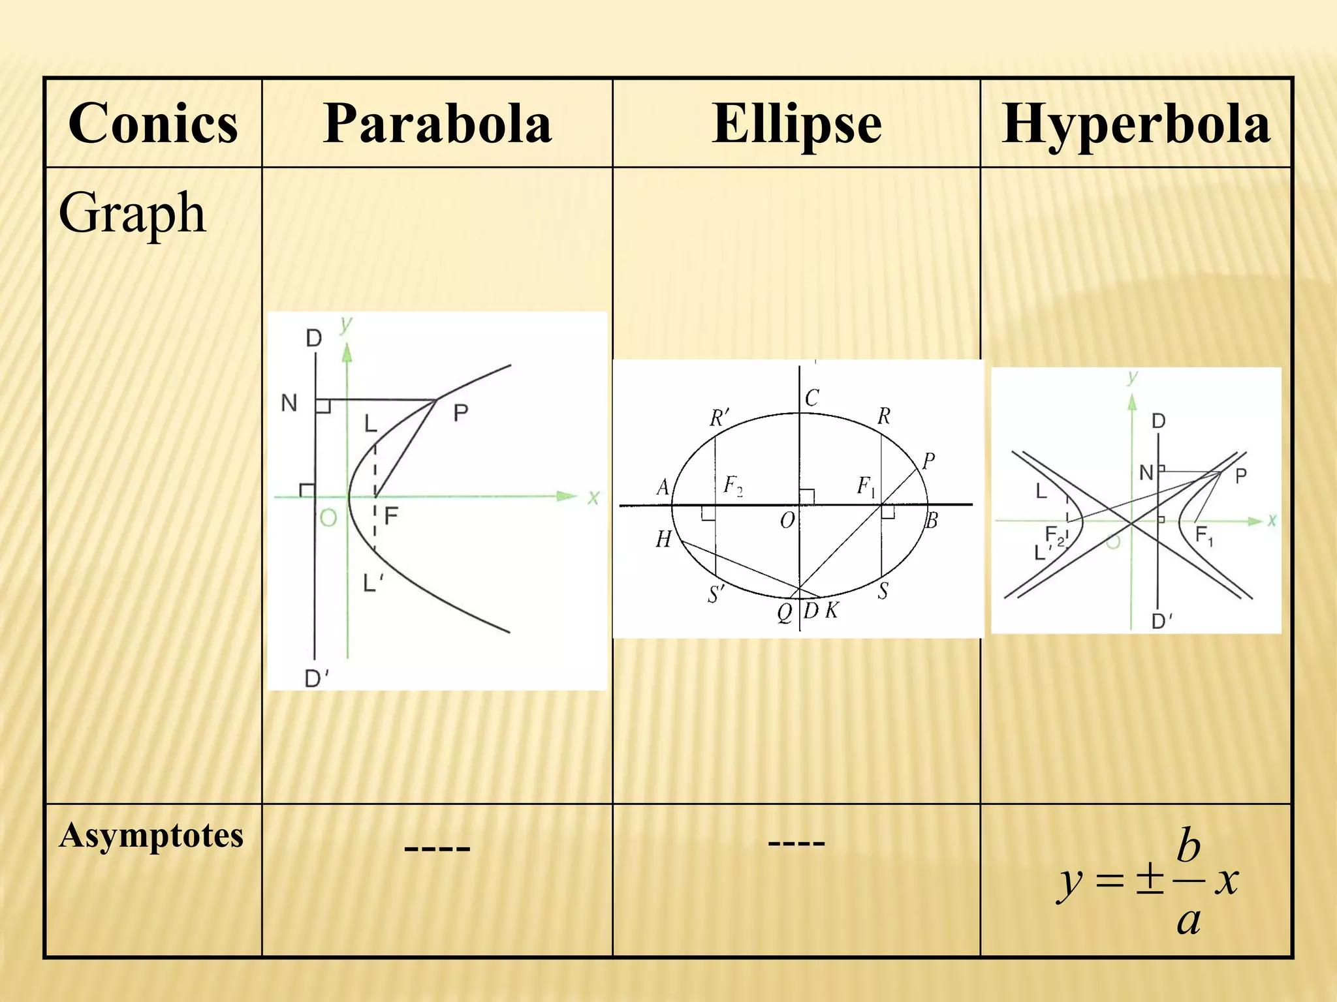
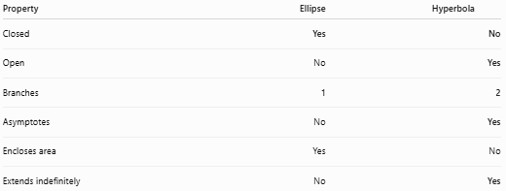
Property | Ellipse | Hyperbola
Closed | Yes | No
Open | No | Yes
Branches | 1 | 2
Asymptotes | No | Yes
Encloses area | Yes | No
Extends indefinitely | No | Yes
This makes the hyperbola particularly important in your Open Curved Shapes classification.

Key Points
# Source: AI Source: Provided by: [Data Path: Persons Table -> ID Column: 1, Name_En Column: Motasem Essam] -> From: [ChatGPT] on [7/25/2026]
An Open Hyperbolic Curve is:
$$\boxed{\text{Open}+\text{Hyperbolic Form}+\text{Continuous Curvature}+\text{Asymptotic Behavior}}$$
It:
- Is based on a hyperbola.
- Has open branches.
- Can open left, right, upward, or downward.
- Has two branches in the complete hyperbola.
- Has asymptotes.
- Can be represented by a reciprocal relationship such as $y=k/x$.
- Can be symmetric or asymmetric depending on the portion considered.
- Does not enclose an area by itself.
- Can extend indefinitely.
Most important distinction
$$\boxed{\text{Hyperbolic Open Curve}≠\text{Elliptical Closed Curve}}$$
A hyperbola is open and has two branches, while an ellipse is closed and has one continuous boundary.

Conclusion
# Source: AI Source: Provided by: [Data Path: Persons Table -> ID Column: 1, Name_En Column: Motasem Essam] -> From: [ChatGPT] on [7/25/2026]
Hyperbolic Open Curves are open curves based on the geometry of hyperbolas. They are characterized by their open branches, changing curvature, asymptotes, and ability to extend indefinitely. They can be classified by their opening direction, branch, symmetry, extent, and orientation.

